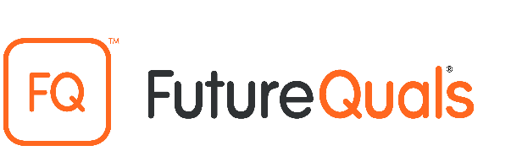
LEVEL 2 FUNCTIONAL SKILLS QUALIFICATION IN ENGLISH: SPEAKING, LISTENING AND COMMUNICATING

RECORD OF LEARNER ACHIEVEMENT

Learner name:
Date of birth: | Learner number:
Work location:

Assessor name:
Assessment task:
Additional assessment requirements:
Additional comments / incidents:

Result (please indicate a pass if the learner has demonstrated  a secure overall performance for each SOS i.e. there is  a tick on each row of the assessment sheet overleaf. Please  indicate a fail if there is a cross on any row of the assessment  sheet overleaf) | Pass | Fail

I declare that the record presented for this assessment is entirely my own work.
Learner signature: | Date:
Assessor signature: | Date:
Internal Quality Assurer signature:  (if sampled) | Date:

This form must be completed and retained by the centre in a secure place for a minimum of 3 years. It must be made available to FutureQuals or your external quality assurer/moderator upon request.

LEVEL 2 FUNCTIONAL SKILLS QUALIFICATION IN ENGLISH: SPEAKING, LISTENING AND COMMUNICATING
ASSESSMENT SHEET

Level 2 overall performance across the range of requirements for the level must be secure; any insufficient demonstration of any individual content statement must be balanced by appropriate demonstration of that same content statement elsewhere.

SOS ref | You must observe the learner doing each of the following consistently across  the sub-tasks. | Insert a tick ()  if yes  Insert a cross (X)  if not.
1 | identify relevant information from extended explanations or presentations?
2 | follow narratives and lines of argument?
3 | respond effectively to detailed or extended questions and feedback?
4 | make requests and ask detailed and pertinent questions to obtain specific information in a range of contexts?
5 | communicate information, ideas and opinions clearly and effectively, providing further detail and development if required?
6 | express opinions and arguments and support them with relevant and persuasive evidence?
7 | use language that is effective, accurate and appropriate to context and situation?
8 | make relevant and constructive contributions to move discussion forward?
9 | adapt contributions to discussions to suit audience, purpose and medium?
10 | interject and redirect discussion using appropriate language and register?

Sub-Task 1 – Assessor evidence/comments:

Sub-Task 2 – Assessor evidence/comments:

This form must be completed and retained by the centre in a secure place for a minimum of 3 years. It must be made available to FutureQuals or your external quality assurer/moderator upon request.

